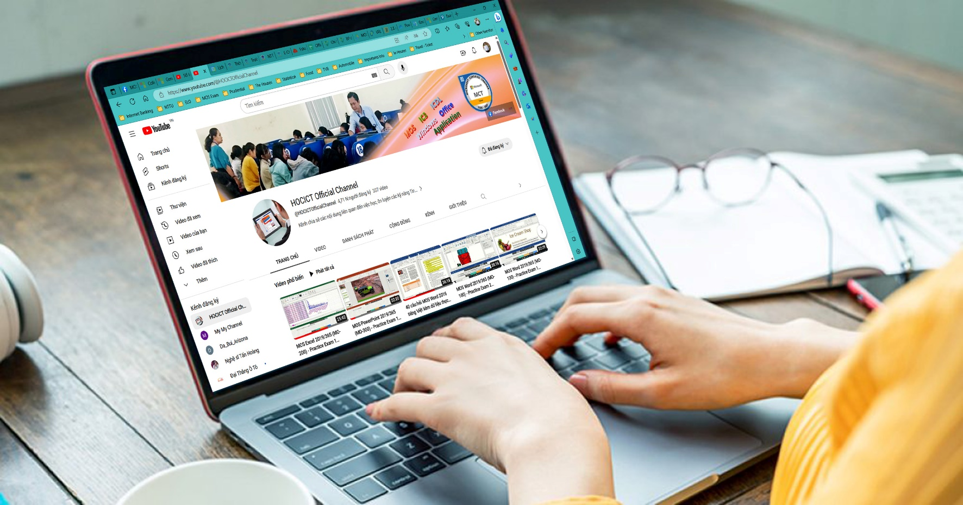

MICROSOFT OFFICE SPECIALIST (MOS) 2019

CERTIFICATION TRAINING
  - HOCICT OFFICIAL CHANNEL

This white paper outlines some best practices that universities can implement to develop programs to help students to get MOS 2019 Certifications.

MICROSOFT OFFICE SPECIALIST (MOS) 2019

CERTIFICATION TRAINING
  - HOCICT OFFICIAL CHANNEL
CONTENTS
MOS CERTIFICATION 2
Microsoft Office Specialist: Associate (Office 2019) 2
MOS Word 2019 Associate 2
MOS Excel 2019 Associate 2
MOS PowerPoint 2019 ASSOCIATE 3
Microsoft Office Specialist: Expert (Office 2019) 3
PROGRAMS AT HOCICT OFFICIAL CHANNEL 3
Overview 3

MOS CERTIFICATION
Pass an exam in a specific Office program to earn a Microsoft Office Specialist certification. Being certified as a Microsoft Office Specialist demonstrates you have the skills needed to get the most out of Office.

Currently, there are 4 versions of the MOS test deployed by Certiport - USA worldwide. In Vietnam, there are 3 versions of the test developed by IIG Vietnam.

Microsoft Office Specialist: Associate (Office 2019)
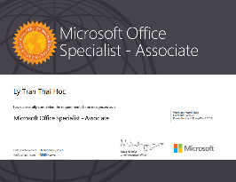
Demonstrate that you have the skills needed to get the most out of Office by earning a Microsoft Office Specialist: Associate certification in multiple Office programs.
To earn the Microsoft Office Specialist: Associate certification, pass three of the following exams:
MO-100: Microsoft Word (Office 2019)
MO-200: Microsoft Excel (Office 2019)
MO-300: Microsoft PowerPoint (Office 2019)
MO-400: Microsoft Outlook (Office 2019)

MOS Word 2019 Associate
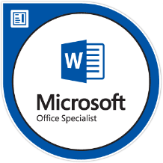
This exam measures competency in the correct application of the principal features of Word by creating and editing documents for a variety of purposes and situations. The exam covers the ability to create and maintain professional-looking reports, multicolumn newsletters, résumés, and business correspondence.

MOS Excel 2019 Associate
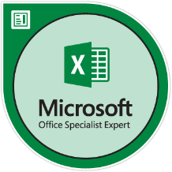
This exam measures competency in the fundamentals of creating and managing worksheets and workbooks, creating cells and ranges, creating tables, applying formulas and functions, and creating charts and objects. The exam covers the ability to create and edit a workbook with multiple sheets and use a graphic element to represent data visually. Workbook examples include professional-looking budgets, financial statements, team performance charts, sales invoices, and data entry logs.

MOS PowerPoint 2019 ASSOCIATE
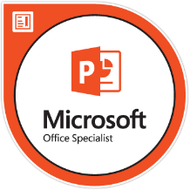
This exam measures competency to create, edit, and enhance presentations and slideshows, including the ability to create and manage presentations, insert and format shapes and slides, create slide content, apply transitions and animations, and manage multiple presentations. Presentation examples include professional-grade sales presentations, employee training, instructional materials, and kiosk slideshows.

Microsoft Office Specialist: Expert (Office 2019)
Demonstrate that you have the advanced skills needed to get the most out of Office by earning a Microsoft Office Specialist: Expert certification in multiple Office programs.
To earn a Microsoft Office Specialist: Expert certification, complete the following requirements:
- Earn a Microsoft Office Specialist Associate certification by passing three of the following Associate exams:
- MO-100: Microsoft Word (Office 2019)
- MO-200: Microsoft Excel (Office 2019)
- MO-300: Microsoft PowerPoint (Office 2019)
- MO-400: Microsoft Outlook (Office 2019)
- Pass any two of the following three Expert exams:
- MO-101: Microsoft Word Expert (Office 2019)
- MO-201: Microsoft Excel Expert (Office 2019)
- MO-500: Microsoft Acces Expert (Office 2019)

PROGRAMS AT HOCICT OFFICIAL CHANNEL

Overview
 Welcome to website http://www.hocict.edu.vn. This website is used for sharing document, lecture, reference material without using storage device. The creators’ purpose is for studying, exchanging and sharing knowledge with positive construction not for profit.
Moreover, students can check studying schedule, exam report, grade, etc. The website’ main contain covers lecture slides, curriculum, exercise is constructed by website owner and his colleagues.
With the vision of sharing our knowledge of Information Technology in general and Informatic in special, we create website HOCICT-Information Communications and Technologies to collect and rearrange educational materials and our own resources.
The website contains many literatures in different categories which have smaller groups so it is more convenience for readers. Besides, there are sections for top read articles, new articles, etc.
Articles in HOCICT.EDU.VN website (Mar 2019)
Category | Quantity | Topic
Informatics Technology | 17 | - MOS  - IC3  - ICDL
Fundamenal | 28 | - Bike Sharing Program  - Bicycle repair shop on campus
Graphical | 20 | - Photoshop  - Corel Draw  - Camtasia
Networking | 15 | - Microsoft  - Cisco  - IBM

Author

Ly Tran Thai Hoc, M.Sc. (I.T)
- Microsoft Certified Trainer - IC³ Global Standard 4 Authorized Educator
- MOS 2019 Expert - MOS 2016 Master – MOS 2013 Master – MOS 2010 Master
📨Email: | ltthoc@hocict.edu.vn
📞Telephone:
🚩Office: | 458/3F Nguyen Huu Tho Str, Tan Hung Ward, District 7, HCMC, Vietnam
🕰Office hours: | From Monday to Friday 7:30 – 16:30  Saturday 7:30 – 11:30
Ly Tran Thai Hoc was born in Long An, Vietnam. He received Master degree of Information Technology (2018) from Ho Chi Minh City University of Technology (HUTECH), Vietnam. He has been working at the NTT Center for Informatics - Nguyen Tat Thanh University, HCMC, Vietnam as a lecturer since 2014 until now.
He is also the founder, manager, and leader of the administration team of fan page hocict.edu.vn and the HOCICT Official Channel on YouTube. All his compiled materials are freely available to the community.
For more information about the author, please visit: https://credly.com/users/ly-tran-thai-hoc

https://learn.microsoft.com/en-us/credentials/certifications/microsoft-office-specialist-associate-2019/
https://learn.microsoft.com/en-us/credentials/certifications/microsoft-office-specialist-expert-2019/

